

**SIMULATION OF INDUSTRIAL AUTOMATION (GIT PLUS LIMITED)**

**BY**

**GROUP 4**

**MEMBERS**

* **MIFETU WISE APEDOVI – ADS20A00163Y**
* **COURAGE SETSOAFIA – ADS20A00175Y**
* **CHIZARAM PAUL – ADS20A00189Y**
* **SA’AD UMAR – ADS20B00333Y**

**QUESTION 1**

**Outline the various values of simulation for flexible automated system design by selecting any establishment of your own**

**GIT PLUS LIMITED**

GIT Plus is an established IT company committed to providing innovative and cost-efficient IT services with advanced state-of-the-art technologies. They understudy their clients to offer them fit-for purpose and appropriate technological solutions. To give their clients the best service and support, GIT Plus combines the dedication and expertise of their in-house team with the support of their international partners, cutting-edge solutions from major international equipment manufacturers and suppliers.

Some various values of simulation for flexible automated system design for GIT Plus, are **the selection of material handling equipment, queue dimensioning, resource allocation, and operational decisions to recovery methods and system management choice**.

The advantages of utilizing simulation to build a flexible automated system are numerous and diverse, spanning from the selection of material handling equipment, queue dimensioning, resource allocation, and operational decisions to recovery methods and system management choice. Basically, every throughput test that would be beneficial to run on the actual system may be done for less money and without endangering the automated system.

**QUESTION 2**

**Present a simulation model element data (this may require not only product or action-specific cycle time data but also change over times)**

The following are the elements that make up simulation models: **system entities, input variables, performance metrics, and functional connections**. For instance, in a simulation model of a consultation queue at **GIT Plus**, the server and the queue are system entities, arrival rate and service rate are input variables, mean wait time and maximum queue length are performance measures, and the sum of the waiting time and service time gives us the time in system. A functional connection is demonstrated in this instance. Every simulation software package offers structures to model each of the aforementioned elements. The most crucial element of a simulation research is probably the modelling. A simulation study is just as valuable as a simulation model.

**QUESTION 3**

**Identify the technological growth in automation with respect to your chosen establishment**

* **High rate of flexibility and increased productivity:** GIT Plus Limited has developed top-notch solutions and made advances using the majority of recent technologies. As a result of innovations, company operations might become more flexible. One of the technologies that has had the most impact on how GIT Plus do business is cloud computing. GIT Plus Limited, frequently find it helpful for performance management and documentation, since they started using this cloud computing technology. Through this new technical platform, they gain flexibility and efficiency while investing less money in the process.
* **The ability to outperform competitors:** GIT Plus has been able to keep a competitive advantage over their competitors ever since they began using various technologies. They employ a first-movers strategy along with the required technologies to develop new products, differentiate those products from those already on the market, and improve customer services. They also devise ways to cut costs through increased productivity and a decreased need for employee overhead.
* **Customer service:** At GIT Plus, the customer service department now make use of some automation technologies or tools like chatbots and automated [text message marketing solutions](https://www.businessnewsdaily.com/15044-best-text-message-marketing-solutions.html). These consumer-facing tools automate typical customer service interactions by answering common enquiries immediately. They only refer customers to a representative when the chatbot is insufficient for handling their needs.

**QUESTION 4**

**Demonstrate the operation of a proposed semi-automatic assembly machine**

One of the proposed semi-automatic assembly machines we selected, is a machine or system designed to provide a semi-automatic assembly process and comprises of a slip chain conveyor, which conveys 8 off pallets, which in turn have inter-changeable tooling to suit the radiator system being assembled.

There are 4 manual workstations, a [leak test](https://www.tqc.co.uk/our-services/leak-testing) station and an unload station along the front edge of the conveyor, the opposite side of the conveyor is simply used to return empty pallets back to the start. of the process.

At each of the manual semi-automatic [assembly stations](https://www.tqc.co.uk/our-services/automation/assembly-benches/), there is an electronic torque driver, a tooling nest for drive bits and an operator interface panel. The leak test station has a manually operated guard that is moved in front of the test piece to protect the operator; this is interlocked to the safety circuit.

This custom designed and manufactured system provided a cost-effective solution to ensure the correct assembly process was adhered to by the operators and combined a final leak test as a quality assurance check for the final automotive radiator assembly. This type of [special purpose machine](https://www.tqc.co.uk/special-purpose-machines-and-custom-built-systems/) is ideal for low volume production of many different variants of parts. New design of parts can be accommodated along the same assembly line by simply designing and manufacturing new tooling pallets.

Below are some operations of the system:

* Flexible, configurable pallet-based system
* Pallet tooling with features to allow lift and rotation of parts
* Assembly tool stations
* Leak test station
* Intelligent power tools
* Local operator control boxes
* Standard Operating Procedure (SOP) display system with 6 PC screens
* Barcode reading for part verification
* Label generation
* Live assembly line data on screen
* System configured for over 100 different part numbers

**QUESTION 5**

**Discuss the simulation system software development that you would adopt for this project and justify your choice**

For this project, MATLAB would be the simulation system software development that was chosen. In order to complete this project successfully, the simulation system would be used.

The most well-known tool with all of its toolboxes is the MATLAB system. When necessary, the derivative vector can be evaluated using the Ordinary Differential Equation solvers that are included into the MATLAB environment. Given that the derivative vector, the model description, follows standard programming conventions.

We will be making use of MATLAB, in python to perform the simulation. In order to make use of MATLAB in python, we imported a library called Matplotlib. Matplotlib is a visualization library that combines other libraries to create visual representations of data. It provides a MATLAB-like interface with its Pyplot module.

**QUESTION 6**

**Create and simulate all the possible ideas concerning your data**

Based on the data we gathered concerning the consultation request process of the establishment (GIT PLUS LIMITED), we conducted an analysis or simulation analysis on the consultation request process, because of some setbacks we observed.

The consultation request process at GIT Plus has two procedures, which one of them is through their website and the other is through their social media platform.

The utilization of these procedures needs to be assessed. In addition, the following modification to the original system is of interest: the frequency of arrival of both parts is exponential with the same respective means as in the original system.

The objective is to obtain the utilization of these procedures for the original system and the modification in a meaningful pattern.

The website consultation request procedure arrives every 10 minutes, and the social media platform arrives every 2 minutes. It takes 20 minutes to route a website procedure and 5 minutes to route a social media procedure to the person in charge of consultation request. Customers have to wait in a queue till the consultation attendant becomes available or finish responding to another customer.

For the simulation, we made use python (which is a programming language) and also python library called matplotlib. Matplotlib is a visualization library that combines other libraries to create visual representations of data. It provides a MATLAB-like interface with its Pyplot module.

Below is a visual or graphical representation of the analysis or simulation we did.

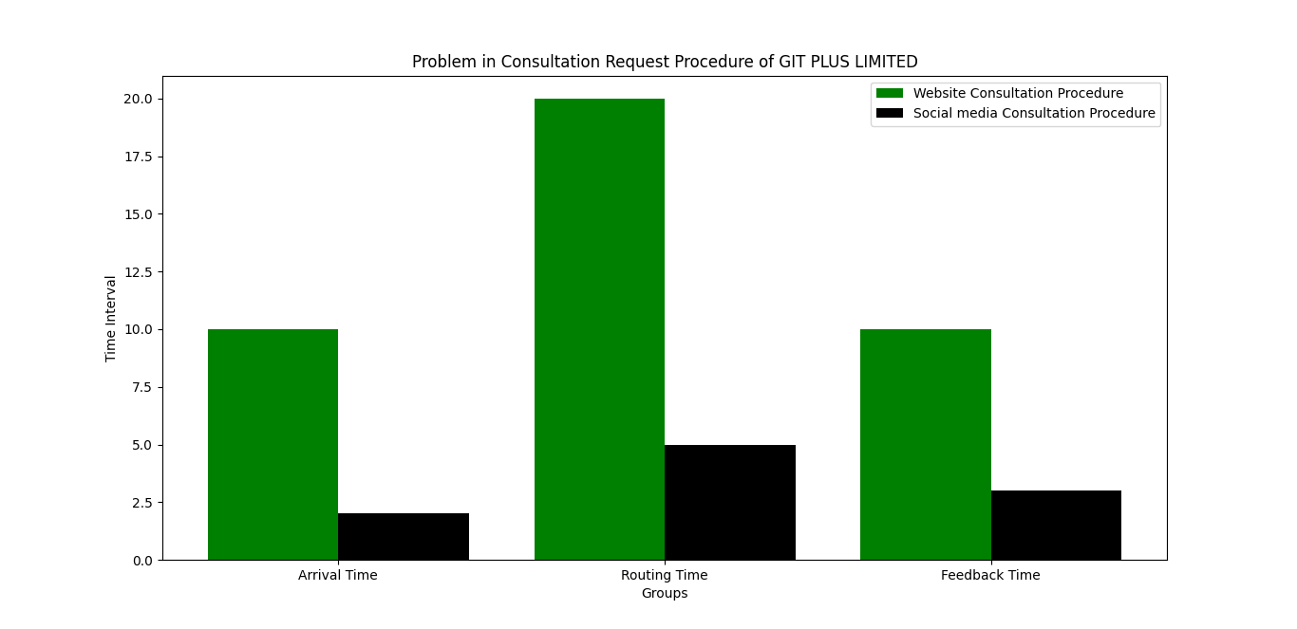

From the above representation, we can see that, the color represents the website procedure and the black color represent the social media procedure. Based on the data we gathered and the analysis we did, we can clearly see from the above graphical representation that,

* When a request is made via the website, it takes a long time, specifically, 10 minutes, for the request to get to the employee in charge of the consultation requests. If a request is done via the company’s social media platform, the message arrives quickly, compared to the website procedure.
* And, connecting or routing the customer to a consultation agent via the website procedure, takes a whole lot of time compared to the social media platform.
* And finally, when a customer makes use of the website to request for consultation, it takes time for the use to get feedback, compared to the social media procedure.

**QUESTION 7**

**Design and verify some pilot run to validate the designed model and to determine other needed conditions for simulation runs**

There are two essential processes in achieving that, and they are the **validation** and **verification** method. These steps serve to validate the created model and define other necessary conditions for simulation runs.

The validation procedure consists of comparing two findings to each other. A comparison is referred to be true when it is valid, and false when it is invalid. Comparing an operational system to a conceptual model in the real world might be done by checking both the proposed or initial model and the operational system (using a statistical or hypothesis testing process). Comparing the final simulation result with analytical findings, recording intermediate results and comparing them with observable outcomes, and testing the simulation model output using a variety of input combinations are a few methods that may be used to assess the design model.

In the verification process, the consistency of two or more results is examined. A comparison is done to assess how accurate the results are. It would be helpful to compare the conceptual descriptions and requirements with the implementation models, their data, and related models. Examining a model's validity, determining a simulation model's representative output, and testing a model utilizing assumptions data are some things to be on the lookout for while validating a model.

These two fundamental stages enable us to evaluate the developed model effectively and economically while also identifying additional prerequisites for simulation runs.

**QUESTION 8**

**Design reports that should be generated from the automation with respect to your chosen establishment**

GIT Plus is an established IT company committed to providing innovative and cost-efficient IT services with advanced state-of-the-art technologies. Due to some setbacks, development errors and other challenges, GIT Plus, face decrease in their productivity and lots of complains for their customer.

In order to aid the firm in understanding the issue, this study was done to come analyze the problem and come up with possible solution to eradicate or eliminate the problem.

The GIT Plus Limited issues were investigated based on data gathering and observation from the organization and their workflow. Also, and simulation and automation strategy were used to simulate the gathered data and come up with possible solution to eradicate the problem faced by GIT Plus.

Based on our findings, we pointed out one major problem faced by the establishment (GIT Plus Limited). Below is one of the major problems:

* **Consultation request procedure:** this problem is one of the major problems that GIT Plus face, that has led to loss of customers and decrease in productivity. The consultation request process at GIT Plus has two procedures, which one of them is through their website and the other is through their social media platform. And based on the analysis we conducted, we concluded that, the two procedures are not that efficient, most especially, the website procedure, which has resulted to a lot of complains from the customers.

Although, this problem has resulted to a lot of setbacks at GIT Plus, the study we carried, and based on the data we gathered and analyzed, we came up with some recommendation or possible solutions, that the organization should implement, in order to eliminate this problem. And these recommendations are as follows:

* Recruiting or employing more consultation request attendants
* Implementing or making use the chat bot technology in their website, in order to increase efficiency and reduce delay in arrival, feedback and routing time

In conclusion, we have been able to conduct an analysis, simulate the data that has been collected, and also come up with solutions to eliminate the problem. With the two recommended solutions carried appropriately by GIT Plus, it will increase their productivity, and their customer service performance.

**QUESTION 9**

**Discuss the testing strategies/techniques that you would use on this project; and provide a table of test criteria and corresponding test data for the testing**

A strategy for software testing integrates software test case design approaches into a well considered series of phases in order to successfully build software or an idea. A testing road map is provided by software testing strategies.

**Acceptance testing** alongside with the **Automated testing (also known as dynamic testing)**, which focuses on the behavior of a product, software, an idea or an organization or establishment are the suggested or chosen technique for this project.

Testing for accuracy, performance, reliability, and security are the four categories under which automated testing is categorized.

User acceptability testing, also known as acceptance testing, is a type of testing carried out to determine whether the concept or product is created or implemented in line with the standards and defined criteria and fulfills all the needs supplied by the customer or business. There are several names for acceptance testing, including validation testing, final testing, QA testing, factory acceptance testing, and application testing. Additionally, acceptance testing may be carried out at two different levels: one at the level of the supplier of the system or concept, and another at the level of the final user.

**Below is the test criteria and the corresponding data:**

|  |  |
| --- | --- |
| **TEST CRITERIA** | **TEST DATA** |
| Customer service criteria | Customer Service Department at GIT Plus Limited |
| Time management criteria | Development and information gathering processes at GIT Plus Limited |
| Consultation request criteria | Arrival time, routing time and feedback time for consultation request procedures at GIT Plus Limited |